

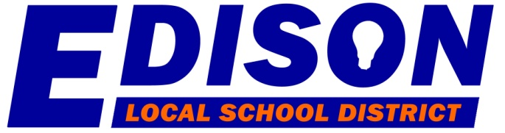

**BOARD OF EDUCATION**

Patricia Cuthbertson—President

Stephen Berry-Vice President

Mark Suhanic

Matthew McClester

Brian Chase

**Mr. Corey L. Ream**

**Superintendent of Schools**

**Stephanie Hanna – Treasurer**

140 S. Main Street

Milan, OH 44846-9735

Phone: (419) 499-3000, ext. 1111

Fax: (419) 499-4859

**______________________________________________________________________________________________________________________________**

**BACKGROUND CHECK INFORMATION**

The Edison Board of Education Office is now able to conduct both FBI and BCI background checks. If you are in need of obtaining a check, please contact Krista Baker in the board office, information below.

Edison Board of Education  
140 S. Main Street, Milan, OH. 44846

419-499-3000 ext. 1111

[kbaker@edisonchargers.org](mailto:kbaker@edisonchargers.org)

**Monday through Friday-By Appointment Only.**   
  
FBI-$30 & BCI $25 (Pricing for Edison School Employees, Coaches, Subs & Volunteers **ONLY**)

FBI $40 & BCI $30 (Pricing for non-Edison school related individuals)   
  
Payment can be made via cash, check or charge. To pay for your checks by credit/debit card, you will need to access the Student Fees Payment System (EFS) via the Edison Chargers website. (Please note that there is convenience charge when using your credit/debit card.) If paying by credit/debit card, you will need to bring a printed receipt verifying your payment. You will also need to have a valid driver’s license available at the time of your check.

The website for additional locations in Erie county is listed below. Please visit the Ohio Attorney General’s website if you have questions regarding background checks.

<https://www.ohioattorneygeneral.gov/Business/Services-for-Business/WebCheck/Webcheck-Community-Listing>

**(press CNTL+Right Click to open link)**